Report
Table of Contents

1. Motivation 2
2. Data description 2
3. Preprocessing 2
4.1. Methodology of classical models 5
4.2. Results for classical models 7
5.1. Methodology of modern models 8
5.2. Results for modern models 11
6. Evaluation & Discussion 12
7. Conclusion 14
8. References 15

1. Motivation
One of the biggest problems of subscription-based companies is customer churn, including telecommunication organisations [1]. At the point of a customer departing, the company forfeits existing revenue and the life value of that contract. Marketing and promotions to get new customers are generally more costly than retention, and thus the ability to predict churn has obvious financial gains. Telecommunication companies are now gathering extensive information about demographics, services subscribed and payment behaviour. Machine learning can be employed to use these data to create churn prediction models [2] A number of classical models are implemented in this project on the Telco Customer Churn data and their performances compared to each other in terms of accuracy and correct identification of churners.

2. Data description
The dataset of the analysis is the Telco Customer Churn open repository that has 7,043 customers of a fictional telecom’s provider. The rows denote the customers, and the target variable Churn indicates whether a customer resigned within the previous month (Yes) or (No).
There are three categories of predictors. Demographics will consist of gender, SeniorCitizen, Partner and Dependents which will capture the basic attributes that can determine the stability of a contract. PhoneService, MultipleLines, InternetService, OnlineSecurity, OnlineBackup, DeviceProtection, TechSupport, StreamingTV and StreamingMovies are examples of service variables that are subscribed to. Contract and billing variables such as tenure, Contract type, PaperlessBilling, PaymentMethod, MonthlyCharges and TotalCharges are variables related to the financial relationship and switching incentives.
The modelling dataset of 7,032 observations and 19 predictors and Churn has been pre-processed with a slight decrease in numbers because of the removal of missing TotalCharges. The percentage of non-churners and churners are close to 73% and 27%, respectively, which means that the evaluation should include considering the class imbalance and should not be based on the accuracy.

3. Preprocessing
To ensure that the dataset was suitable for modelling, several preprocessing steps were undertaken. These steps aimed to correct data-quality issues, harmonise variable formats, and prepare the inputs required for both classical and flexible machine-learning models.

3.1 Handling missing values and correcting variable types
The variable TotalCharges was stored as a character vector because 11 entries contained blank spaces rather than numeric values. These blank entries were first converted to NA, after which all incomplete rows were removed. This resulted in a final modelling dataset of 7,032 complete observations. The variable was then converted to numeric to reflect its interpretation as a continuous billing-related measure:

3.2 Conversion of variables to appropriate formats
The target variable Churn was encoded as a two-level factor with "Yes" representing the positive class. Several variables required harmonisation:
- Demographic variables (gender, SeniorCitizen, Partner, Dependents)
- Service and subscription variables (InternetService, OnlineSecurity, TechSupport, etc.)
- Account-based variables (Contract, PaperlessBilling, PaymentMethod)
These were converted to factors to ensure correct treatment in classification algorithms. Numeric variables such as tenure, MonthlyCharges, and TotalCharges were retained as numeric.
The unique identifier customerID was removed, as it carries no predictive information and may introduce noise into the modelling process.

3.3 Train–test split
A 70/30 stratified train–test split was used to preserve the original churn distribution (~27% churn) in both subsets. This produced 4,924 training and 2,108 test observations.

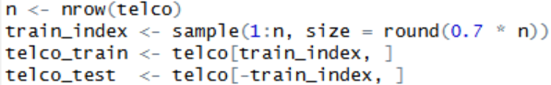

Maintaining the class proportions in each split helps avoid biased performance estimates, especially in imbalanced classification settings.

3.4 Preparing inputs for models requiring numeric predictors
Some models used in this project—particularly Boosting (GBM) and the Neural Network (MLP)—require all predictors to be numeric. To satisfy this requirement, categorical variables in the training and test data were converted into dummy variables using model.matrix(), generating a binary design matrix of 0/1 indicator variables for each factor level.

Because most predictors became 0/1 indicators, and the remaining continuous variables (e.g., MonthlyCharges, TotalCharges) were on moderate scales, additional standardisation was not strictly required for the neural-network implementation used (nnet package).

Summary
These preprocessing steps ensured that:
- missing and invalid data were removed,
- variables were encoded consistently,
- class proportions were preserved across training and test sets,
- and models requiring numeric inputs received appropriately structured data.
This produced a clean and coherent dataset suitable for all classical and flexible machine-learning methods implemented in the study.

4.1. Methodology of classical models
The classical machine learning algorithms were used, including logistic regression (GLM), Random Forest, Support Vector Machine (SVM) radial kernel, and k-Nearest Neighbours (kNN). The predictors were the same set of predictors based on the preprocessing step, and the outcome is Churn, which is a binary variable [3].
Logistic regression (GLM). Logistic regression is a lineal model of the log-odds of churn that is a linear combination of the predictors. It was specified with glm function with the binomial family. The dichotomous variables underwent an internal encoding in the form of dummies. Logistic regression gives interpretable coefficients which show the direction and the strength of association of each predictor with churn, which is relative. It is a model of natural baseline due to its simplicity and known statistical characteristics.
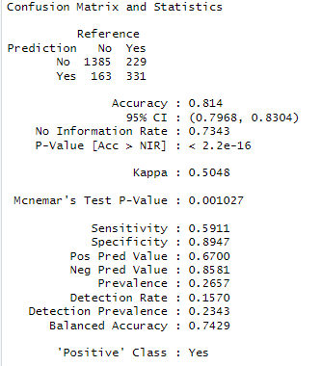

Random Forest
The Random Forest model combines many decision trees to create an ensemble classifier (Salman, Kalakech and Steiti, 2024). Each tree is fitted on a bootstrap sample of the training data, and, at each split, a random subset of predictors is considered. This randomness reduces correlation between trees and improves generalisation. The model was trained using the randomForest package with 500 trees (ntree = 500) and mtry = 5 predictors randomly selected at each split. The algorithm is able to capture complex non-linear relationships and interactions between variables. The fitted model also provides variable importance measures, which were visualised to identify the strongest drivers of churn.
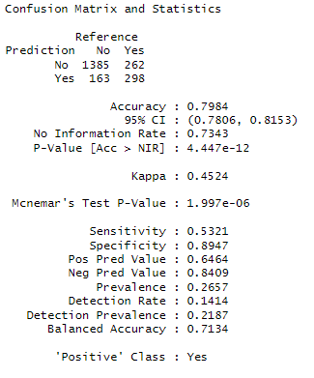

Radial kernel Support Vector Machine (SVM)
SVM seeks to identify a decision boundary that will create maximum distance between the two classes in a high-dimensional feature space. The radial basis function (RBF) kernel has been taken due to the fact that the churn might not be linearly separable in the original predictor space. The svm function of e1071 package was used to train the SVM with the cost = 1 and gamma = 0.1. These parameters are the trade-off of margin width and misclassification, and decision boundary flexibility, respectively.
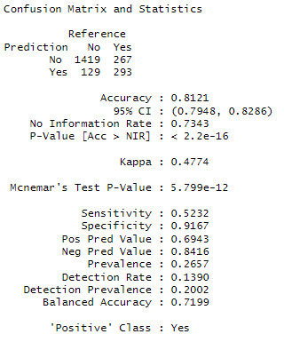

k-Nearest Neighbours (kNN)
kNN is a distance-based classifier that makes predictions on the basis of the majority class of the nearest training neighbours with respect to the distance of the new observation. It does not learn model parameter explicitly, but it uses the structure of training data. Caret was used to transform the kNN model with 5-fold cross-validation to restate k. The tuning grid tried various values and chose k = 23 as the optimal one by using cross-validated performance.
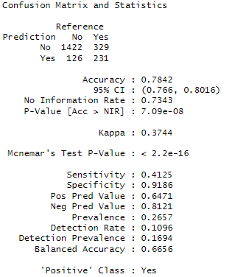
On the test set, predicted labels were produced on each model. The confusion matrix and three measures were used to sum up performance, namely accuracy, sensitivity (true positive rate - proportion of churners correctly identified) and specificity (true negative rate - proportion of non-churners correctly identified). The sensitivity of the matter is under consideration especially since the loss of an at-risk customer as a result of not identifying them can be an untapped opportunity.

4.2. Results for classical models
Table 1: Performance of classical models on the Telco churn test set
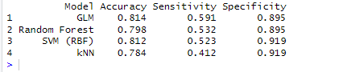
The logistic regression model has a total accuracy of the highest at 81.4% and a good specificity of 89.5% implying that it identifies most of the non-churners. Also, its sensitivity is the highest of the models (59.1%) but still approximately two out of five churners go unnoticed. In a retention environment since the penalty associated with false flagging a non-churner is often less than the penalty associated with the failure to flag a true churner, this would suggest that GLM is likely the best model.
Random Forest model gives slightly reduced overall accuracy (79.8%) and a lower sensitivity (53.2%). It thus detects a lower percentage of churners though with the same specificity (89.5%). The results obtained in the form of the importance of variable in the random forest show that tenure, TotalCharges, Contract, MonthlyCharges and InternetService are rated among the greatest influencing predictors, which is as per the expectations in the domain.
SVM model is just as accurate as the logistic regression (81.2%) and specificity is highest (91.9%) but sensitivity is lower (52.3%). It is a conservative behaviour, and it will occur with very few predictions of churn, thus limiting its applicability in proactive intervention. Lastly, the weakest performance is shown by kNN with accuracy of 78.4% and sensitivity of 41.2% with specificity being high (91.9%). This implies that in this high dimensional model with a combination of numeric and categorical variables, kNN cannot effectively differentiate between churners and non-churners.
Generally, this is a trade-off between churner detection and false positives. In the context of churn early detection with targeted retention response, the Logistic regression model represents the most appropriate classical model of the tested ones having the highest accuracy, sensitivity and being interpretable, therefore also useful as a baseline model when the model transparency matters to the stakeholders.

5.1. Methodology of modern models
This section describes each model in detail, including assumptions, fitting procedures and tuning parameters.

Linear Discriminant Analysis (LDA)
LDA was used as a baseline classifier due to its interpretability and closed-form structure. The model assumes multivariate normality within each class and a shared covariance matrix, leading to linear separation boundaries. It estimates the discriminant function:
$$δ_{k}(x)=x^{⊤}Σ^{-1}μ_{k}-\frac{1}{2}μ_{k}^{⊤}Σ^{-1}μ_{k}+log⁡(π_{k}),$$
where $π_{k}$is the prior probability of class $k$.
The model was fitted using:
A multicollinearity warning was observed, reflecting correlations among services (e.g., OnlineSecurity and TechSupport). LDA still performed well, offering a reasonable benchmark for more flexible models.

Decision Tree (rpart)
A decision tree partitions the feature space into a set of axis-aligned rules that predict the outcome. Trees are fully non-parametric and can capture nonlinear interactions without requiring transformations.
The model was fitted using:
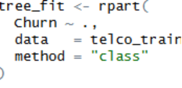
Cost-complexity pruning was undertaken using the cp value that minimised cross-validated error:
Although the unpruned tree achieved slightly higher accuracy, pruning reduces variance and is preferred for generalisation.

Boosting (GBM)
Boosting sequentially fits weak learners—here, decision stumps—to correct residual errors at each iteration.
The gbm model was trained with:
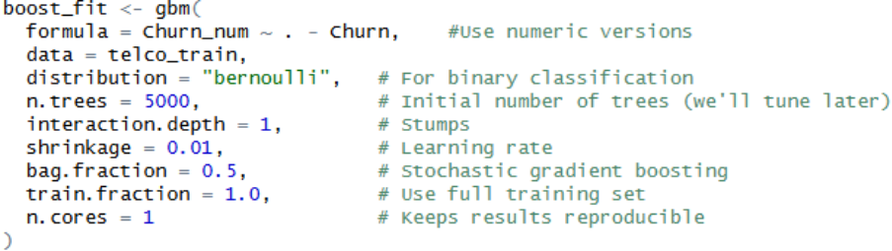
Out-of-bag estimation selected an optimal iteration count of ~925 trees using:
Boosting revealed that the following variables were the strongest predictors:
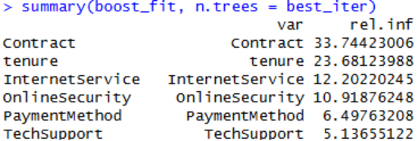

Neural Network (MLP)
A single-hidden-layer neural network was fitted using the nnet package to capture potential nonlinear relationships between the predictors and churn outcome. Neural networks form predictions by applying weighted linear transformations to the input variables, followed by nonlinear activation functions, allowing the model to represent complex decision boundaries that cannot be captured by linear methods such as LDA.
The predictors supplied to the neural network consisted of the dummy-encoded design matrix generated by model.matrix(). This matrix includes a large number of 0/1 indicator variables corresponding to the levels of each categorical predictor, along with a small number of continuous variables such as tenure, MonthlyCharges and TotalCharges. These encoded predictors were used directly as inputs to the network without additional scaling, as the dominance of binary indicators kept most predictors on a broadly comparable scale, and the model demonstrated stable convergence in practice.
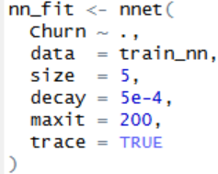
An initial implementation mistakenly included a numeric copy of the target (Churn_num) as a predictor, which led to unrealistically perfect accuracy (100%) due to target leakage. After identifying this issue, Churn_num was removed from the predictors and the model was refitted using only valid inputs.

5.2. Results for modern models
Model performance was evaluated on the test set using accuracy, sensitivity, and specificity. Sensitivity is particularly important in churn-prediction contexts, as failing to identify a churner represents lost intervention opportunities (loss of a customer).
Table 2: Performance of modern models on the Telco churn test set
Model | Accuracy | Sensitivity | Specificity
LDA | 0.808 | 0.570 | 0.894
Decision Tree | 0.801 | 0.479 | 0.925
Boosting | 0.818 | 0.504 | 0.932
Neural Network | 0.814 | 0.493 | 0.930

Table 2 summarises the performance of the four modern models in this part of the project—LDA, Decision Tree, Boosting and the Neural Network—using the test set. As with the classical models assessed by my project partner, performance was evaluated using accuracy, sensitivity and specificity, providing a more complete picture of how each model behaves under the inherent class imbalance of the dataset (≈27% churners).
The LDA model achieved an accuracy of 80.8%, performing slightly below the boosting and neural network models but demonstrating the highest sensitivity of all four methods at 57.0%. This indicates that LDA identifies a larger proportion of churners than the other models, despite its linear assumptions. Its specificity of 89.4% shows solid performance in detecting non-churners. These results suggest that LDA offers a well-balanced baseline, with surprisingly competitive sensitivity given its simplicity.
The decision tree obtained a comparable accuracy of 80.1% but had the lowest sensitivity (47.9%). Its specificity was high (92.5%), reflecting a strong bias toward predicting the majority class (“No churn”). This pattern is common in decision trees trained on imbalanced datasets, as the model tends to favour splits that reduce overall misclassification error rather than improving detection of the minority class. Although highly interpretable, the tree is less effective for identifying at-risk custoers.
Boosting delivered the strongest overall performance with an accuracy of 81.8%, alongside specificity of 93.2%, the highest among the four models. Sensitivity (50.4%) was moderate—higher than the tree but slightly lower than LDA. Boosting’s superior accuracy reflects its ability to iteratively correct residual errors and capture nonlinear interactions. Its variable importance output aligns with domain expectations, with Contract and tenure emerging as dominant predictors of churn.
The neural network achieved an accuracy of 81.4%, placing it close to boosting, with sensitivity of 49.3% and specificity of 93.0%. This shows that even a relatively small network with one hidden layer performs competitively on this tabular dataset. While neural networks can model nonlinear relationships, boosting typically performs better in this domain, which is consistent with findings in churn prediction literature.
Across all four models, specificity consistently exceeded sensitivity, indicating that correctly identifying churners remains the more challenging aspect of the prediction task. While boosting and the neural network achieved the highest overall accuracy, LDA was the most effective at detecting churners. The decision tree, though interpretable, performed least well in this regard. These results emphasise the importance of evaluating models using more than just accuracy, particularly in applications like churn prediction where identifying the minority class is crucial.

6. Evaluation & Discussion
This section evaluates the performance of all models and addresses the research questions outlined for the project. The results from both the classical and flexible modelling approaches are synthesised to provide a comparative and business-oriented interpretation of the findings.

6.1 Can customer churn be effectively predicted using the available variables?
The results across all eight models indicate that churn can be predicted with a relatively high degree of accuracy. Most models achieved accuracy levels between 78% and 82%, demonstrating that demographic, service-related, and account variables contain meaningful information about customer behaviour. Even the simplest models performed well, suggesting that the dataset captures strong structural patterns associated with churn.
These findings confirm that the available predictors are suitable for modelling churn and for supporting data-driven retention strategies.

6.2 Which classification method provides the most accurate and reliable churn predictions?
When accuracy is used as the primary performance metric, boosting achieved the strongest results, followed closely by logistic regression and the neural network. However, accuracy alone is not sufficient in the context of churn prediction due to the imbalanced class distribution. Because churners form only around 27% of the customer base, misclassifying them carries a significantly higher business cost than misclassifying non-churners.
When focusing on sensitivity—the ability to correctly identify churners— the GLM and LDA models clearly outperformed all other models with GLM having the highest as well as having higher both accuracy and specificity. This makes logistic regression the most reliable method for practical churn detection, where identifying customers at risk is more valuable than maximising overall accuracy.
In contrast, boosting and the neural network tended to favour the majority class, resulting in higher specificity but lower sensitivity.

6.3 How do classical models compare with flexible models such as random forests, boosting and neural networks?
The classical models (logistic regression, LDA, kNN, and basic decision trees) were a very mixed bag. Logistic regression and LDA provided strong interpretability and competitive accuracy as well as clearly the highest two sensitivity scores albeit with lower specificity scores. Decision trees and especially kNN both had lower than average accuracy scores and significantly lower sensitivity scores indicating difficulty in capturing nonlinear relationships and interactions within the data and therefore struggled to detect churners effectively.
The flexible models demonstrated a different set of strengths. Boosting and neural networks achieved the highest accuracy and specificity, reflecting their ability to model complex patterns. Random Forest, although also a flexible model, seemed to not excel at any particular category of evaluation, placing somewhere in the middle for all of these categories.
Overall, flexible models outperform classical ones on accuracy and their ability to model nonlinearities. However, classical models (logistic regression and LDA) managed to outperform in sensitivity scores, these models are also valuable for interpretability and transparency, which are important for understanding customer behaviour and informing business strategies.

6.4 Which features contribute most strongly to predicting churn?
Across both classical and flexible models, several predictors consistently emerged as key drivers of churn:
- Contract type (month-to-month customers are most likely to churn)
- Tenure, with shorter-tenure customers showing substantially higher churn rates
- MonthlyCharges, reflecting the financial impact of service pricing
- OnlineSecurity and TechSupport, suggesting that customers lacking support or protection services may be less satisfied
- InternetService type, linked to the quality and reliability of connectivity
These findings align with patterns commonly observed in telecommunications churn studies. Contract structure and service charges appear to be the most influential determinants, followed by the breadth of support services included in the subscription.

6.5 Overall assessment and implications
The evaluation indicates that churn can be predicted effectively using the available variables and that model choice should depend on organisational priorities. If the goal is to maximise correct identification of churners, logistic regression is the most suitable approach. If interpretability is required, logistic regression provides a transparent alternative with competitive performance. For organisations prioritising overall accuracy, boosting offers the strongest results.
Ultimately, the models agree on the key factors influencing churn, highlighting actionable areas for customer retention strategies. Providing longer-term contract incentives, adjusting pricing structures, and offering enhanced support services may help reduce churn in vulnerable customer segments.

7. Conclusion
This project evaluated a range of classical and flexible classification methods to determine their effectiveness in predicting customer churn. The results show that churn can be modelled accurately using demographic, service-related, and account-based variables, with overall accuracies across models consistently above 78%.
While boosting achieved the highest accuracy, logistic regression demonstrated the strongest sensitivity, making it the most reliable model for detecting customers at risk of churning—an essential requirement in business contexts where retaining high-value customers is a priority. Logistic regression is also usable for interpretability, offering a clear understanding of how key factors such as contract type, tenure, and service features influence churn.
Therefore, the best overall model from our findings is logistic regression as it has not only the best sensitivity and interpretability it also has very strong accuracy.
Overall, the findings highlight the importance of contract structure, service pricing, and the availability of support services in shaping customer retention outcomes. These insights can assist telecommunications providers in developing targeted interventions aimed at reducing churn and improving long-term customer loyalty.

8. References
[1] J, S. et al. (2023) 'E-commerce customer churn prevention using machine learning-based business intelligence strategy,' Measurement Sensors, 27, p. 100728. https://doi.org/10.1016/j.measen.2023.100728.

[2] Amin, A., Anwar, S., Adnan, A., Nawaz, M., Alawfi, K., Hussain, A. and Huang, K. (2017) ‘Customer churn prediction in the telecommunication sector using a rough set approach’, Neurocomputing, Volume 237, pp. 242-254. https://www.sciencedirect.com/science/article/pii/S0925231216314849?via%3Dihub

[3] Palaniappan, R. (2024) 'Comparative analysis of Support Vector Machine, Random Forest and K-Nearest Neighbor classifiers for predicting remaining usage life of roller bearings,' Informatica, 48(7). https://doi.org/10.31449/inf.v48i7.5726.

